

Department of CSE (Data Science)
Academic Year 2026 – 2027
Subject: Business Intelligence (23UDSPEL4704) — TAE 1
REPORT TITLE

Cleaning and Analyzing Raw Daily Mandi Commodity Price Data to Improve Agricultural Market Price Intelligence and Forecasting

1. Student Credentials
Field | Member 1 | Member 2
Full Name | Devyani Daphal | Devyani Shinde
Roll Number | P13 | D65
PRN | 23ACDS1101109 | 24DCDS1101045
Section | P | D

Guided By
Mr. Chinmay Mukim

1. Problem Statement & Business Value
India's agricultural marketing system operates through more than 3,000 regulated markets (mandis) spread across every state, each independently reporting the daily minimum, maximum, and modal wholesale price of the commodities traded there. This data is published through the AGMARKNET portal and made available via the Government of India's Open Government Data (data.gov.in) platform. While the raw feed is rich and granular, it is fragmented: prices are reported market-by-market with inconsistent naming, non-standard grading scales, and no unified structure that lets a stakeholder compare prices across mandis, districts, or states on demand.
Business Domain: Agricultural Commodity Marketing / Agri-Supply Chain Business Intelligence.
Key Operational Bottlenecks:
- No single-pane view of price trends across 420+ markets and 149 commodities, forcing manual, mandi-by-mandi lookup.
- Inconsistent commodity, variety, and grade naming across markets prevents reliable state-level or national-level roll-ups.
- Price volatility (spread between minimum and maximum price within the same market) is not currently surfaced as an analytical signal for traders or policymakers.
- Data is published as daily snapshots with no persistent historical warehouse, so trend and seasonality analysis is not directly possible from the source.
Target Decision-Makers:
- State Agricultural Marketing Boards / APMC administrators monitoring regional price stability.
- Agricultural traders, commission agents, and Farmer Producer Organizations (FPOs) deciding where to sell or source a commodity.
- Government policy stakeholders tracking Minimum Support Price (MSP) compliance and price-stabilization interventions.
- Agritech advisory platforms that push price recommendations to farmers.
Target KPIs to be enabled: modal price trend by commodity/state/mandi over time; price spread (Max − Min) as a market volatility indicator; day-on-day and week-on-week % price change; market-reporting completeness (data availability KPI); and identification of the best-price market for a given commodity on a given day.

2. Literature & Industry Survey
A preliminary survey of recent research and industry work using AGMARKNET-sourced data was conducted to validate the business relevance and known data-quality characteristics of this dataset:
- A 2025 study published in Scientific Reports evaluated statistical, machine-learning, and deep-learning models (including ARIMA, XGBoost, and LSTM/GRU networks) for forecasting the prices of 23 agricultural commodities using AGMARKNET daily wholesale price data spanning 2010–2024 across 165 markets, finding that deep-learning sequence models captured price volatility more effectively than classical statistical approaches.
Source: "Enhancing agricultural commodity price forecasting with deep learning," Scientific Reports / Nature, 2025.
- A separate 2024 study in Scientific Reports built exogenous-variable-driven deep learning models (NBEATSX, TransformerX) to forecast prices of Tomato, Onion, and Potato using AGMARKNET price data combined with weather variables, reporting that models incorporating external factors consistently outperformed models trained on price history alone.
Source: "Exogenous variable driven deep learning models for improved price forecasting of TOP crops in India," Scientific Reports, 2024.
- An arXiv study on crop price forecasting quality specifically documented that the AGMARKNET feed is updated daily except Sundays, and that reporting gaps occur irregularly on weekdays as well, re4. Raw Dataset Source & Sourcing Proof

3 Dataset Identity
Dataset Name: "Current Daily Price of Various Commodities for Various Markets (Mandi)"
Publishing Authority: Directorate of Marketing & Inspection (DMI), Department of Agriculture and Farmers Welfare, Ministry of Agriculture and Farmers Welfare, Government of India, via the AGMARKNET portal (agmarknet.gov.in), re-published as open data.
Catalog Page: https://www.data.gov.in/catalog/current-daily-price-various-commodities-various-markets-mandi
Resource / API Endpoint: https://api.data.gov.in/resource/9ef84268-d588-465a-a308-a864a43d0070 (accessed with a personal data.gov.in API key; supports CSV, JSON, and XML output formats).
License: Released under the National Data Sharing and Accessibility Policy (NDSAP) of the Government of India.

4. Sourcing Proof — Why This Is Raw, Non-Kaggle Data
- Pulled directly from the live government API resource (resource ID 9ef84268-d588-465a-a308-a864a43d0070), not from any third-party or pre-cleaned repository.
- Column headers are exported exactly as the source system encodes them, including literal URL-encoding artifacts (e.g. 'Min_x0020_Price'), which is direct proof the file has not passed through any prior cleaning or renaming step.
- The file is a single-day operational snapshot (Arrival_Date = 28-07-2026) with no aggregation, deduplication, or imputation already applied — a genuine historical dataset will require repeated daily pulls that this team will schedule and accumulate.
- No target/label column, no train-test split, and no accompanying documentation of 'cleaned' status — all hallmarks that distinguish this from a tutorial-ready CSV.

5. Dataset Profile (as sourced)
Metric | Observed Value
Total records (single-day pull, 28-07-2026) | 7,181
States covered | 20
Districts covered | 160
Markets (mandis) covered | 420
Distinct commodities | 149
Distinct varieties | 218
Distinct grade labels | 12 (non-standardized)
Price fields | Min, Max, Modal price (₹ per quintal)

6. Identified Raw Data Issues
Issue | Description (observed in the sourced file) | Business / Analytical Impact
Malformed / encoded column headers | Price fields exported as 'Min_x0020_Price', 'Max_x0020_Price', 'Modal_x0020_Price' — raw XML/URL-encoded space artifacts (_x0020_) carried straight from the source API schema. | Breaks direct use in BI tools; requires header remapping
Inconsistent grading scale | 12 distinct, non-comparable grade labels observed across commodities (e.g. Large/Medium/Small, FAQ/Non-FAQ, Grade A/B/C, Grade Range-1/2/3, Local) with no unified scale. | Prevents apples-to-apples quality comparison across mandis
Inconsistent commodity / variety naming | Similar-looking but distinct commodities (e.g. 'Bitter gourd' vs 'Bottle gourd'), plus spelling variants (e.g. 'Corriander seed' vs 'Coriander(Leaves)') and a Variety field that sometimes duplicates the Commodity name and sometimes doesn't. | Risk of merging or double-counting unrelated commodities in aggregation
Single-day snapshot per pull | Each API/CSV pull returns only one Arrival_Date; a genuine time series requires scheduled, repeated pulls stitched together, and the source is known to have non-reporting days (markets closed Sundays, occasional outages). | No time-series analysis possible without a multi-day ingestion strategy
No native primary key | Records carry no unique ID; uniqueness must be constructed from the composite of State + District + Market + Commodity + Variety + Arrival_Date. | Risk of silent duplication on repeated ingestion runs
Embedded punctuation / free-text noise | Market and District names embedded with commas and parentheses inside quoted fields (e.g. "Kozhikode(Calicut)", "Mukkom Market"), and multi-word commodity names with inconsistent bracket usage. | CSV parsing errors and join-key mismatches if not handled carefully
Wide, commodity-dependent price range | Modal prices range from ₹1 to ₹1,02,500 per quintal across 149 heterogeneous commodities in the same column. | Naive outlier detection (e.g. global IQR) would wrongly flag legitimate high-value spice/commodity prices

7. Proposed Methodology & Architecture
The proposed system ingests the raw daily mandi price feed, profiles and cleans it, models it into a dimensional warehouse, and surfaces it through an analytical dashboard. The design keeps ingestion, cleaning, warehousing, and reporting as separate, independently verifiable stages so that TAE 2 can extend any single stage (e.g. swapping the forecasting model) without disturbing the rest of the pipeline.
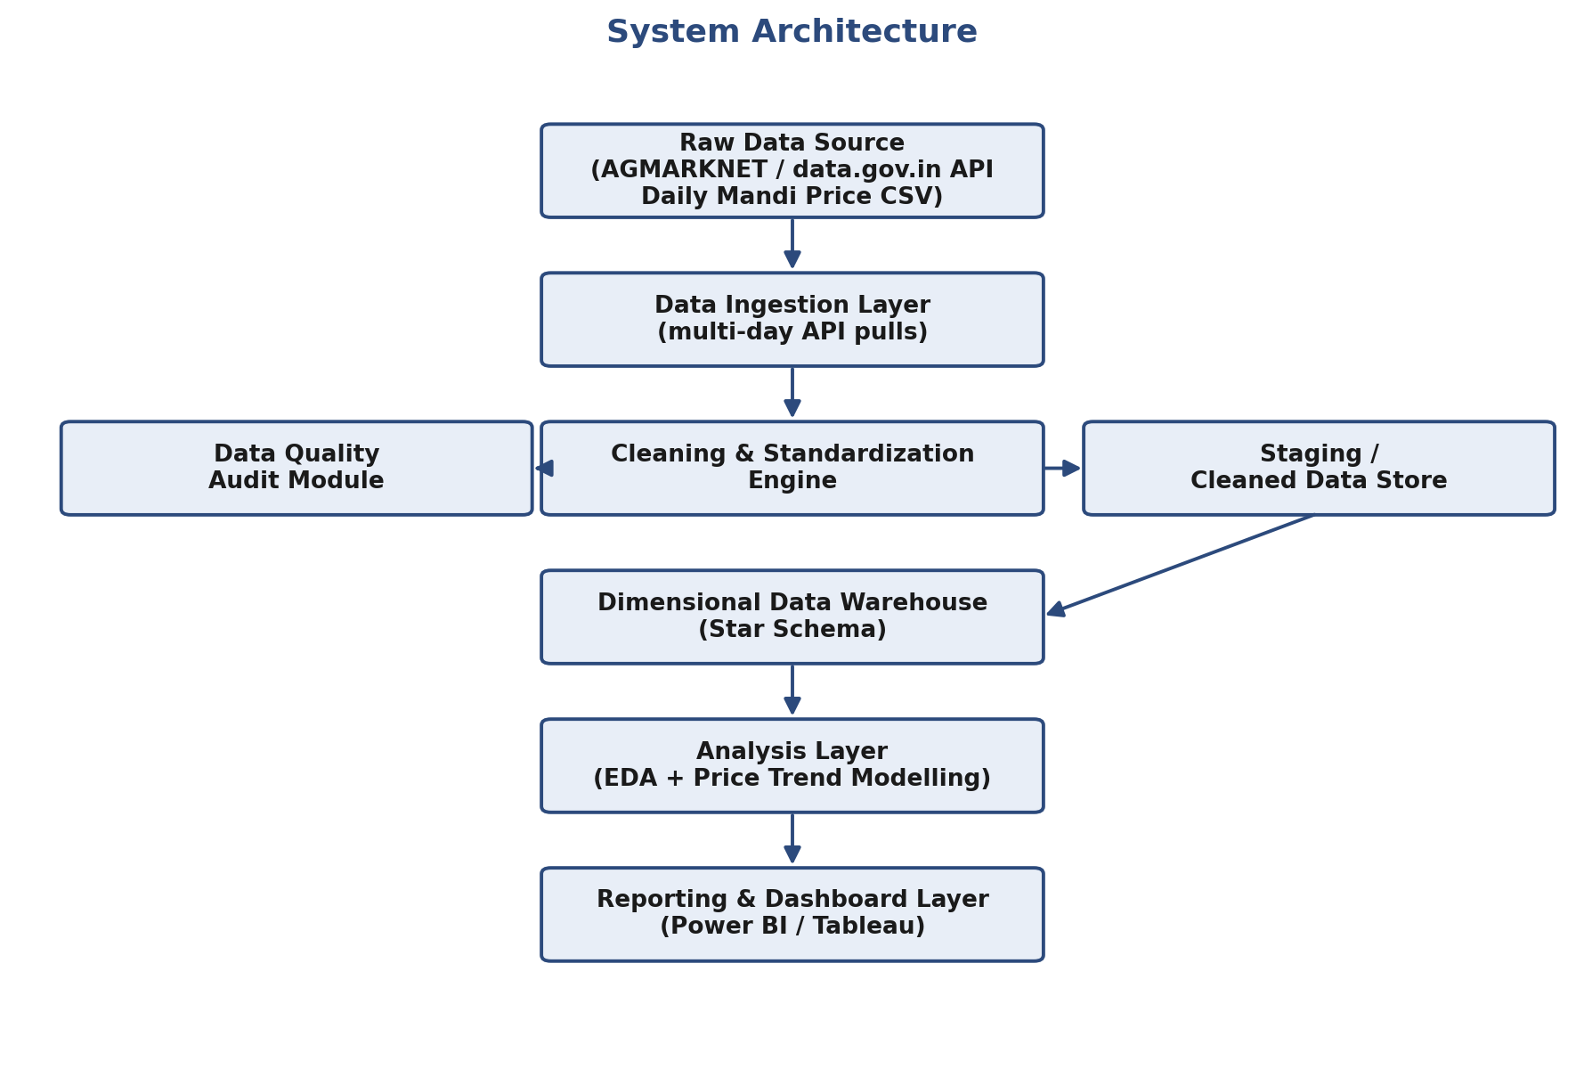
Figure 1: High-level system architecture, from raw API ingestion through to the reporting layer.
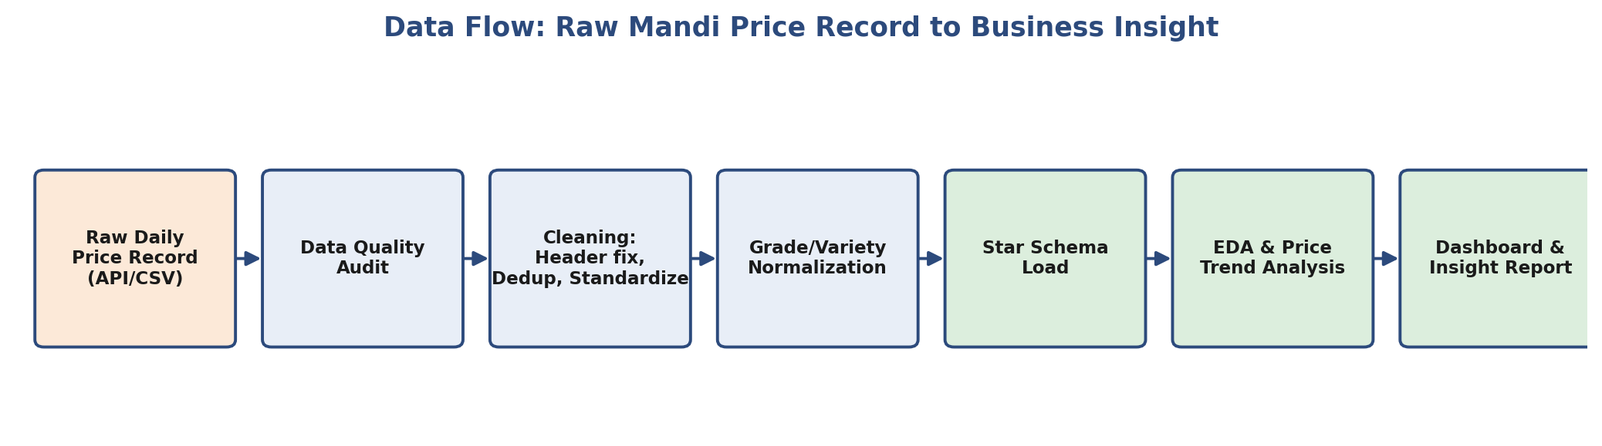
Figure 2: End-to-end data flow for a single mandi price record.

7.1 Data Cleaning / ETL Plan
- Header remediation: rename encoded columns (Min_x0020_Price → min_price, etc.) and enforce correct data types (numeric prices, date-typed Arrival_Date).
- Deduplication: enforce uniqueness on the composite key (State, District, Market, Commodity, Variety, Arrival_Date) to catch repeated ingestion of the same record.
- Grade & variety standardization: build a lookup/mapping table to normalize the 12 raw grade labels into a consistent quality scale, and reconcile Commodity–Variety naming inconsistencies.
- Commodity-aware outlier handling: apply IQR/percentile-based outlier checks within each commodity group (not globally), since price ranges are not comparable across commodities.
- Multi-day accumulation: schedule repeated pulls from the same API resource to build a genuine historical time series rather than relying on a single snapshot.
- Referential integrity: validate Max_Price ≥ Modal_Price ≥ Min_Price on every record and flag violations for review.

7.2 Target Schema Design — Star Schema
Fact Table — Fact_Price: Date_Key, Market_Key, Commodity_Key, Grade_Key, Min_Price, Max_Price, Modal_Price, Price_Spread (derived: Max − Min).
Dimension Tables:
- Dim_Date — Date, Day, Week, Month, Quarter, Year, Is_Reporting_Day
- Dim_Location — Market, District, State, Region
- Dim_Commodity — Commodity, Variety, Commodity_Category (Vegetable/Spice/Cereal/etc.)
- Dim_Grade — Standardized_Grade, Raw_Grade_Label (for traceability back to source)
A Star Schema is proposed over Snowflake for Phase II because the dimension tables here are shallow (no deep sub-hierarchies beyond Commodity→Variety and Market→District→State), so a star design keeps query performance high for dashboard-level aggregation, which is the primary Phase II deliverable.

7.3 Primary Tools
- Python (pandas, NumPy) — ingestion, auditing, and cleaning pipeline.
- SQL (PostgreSQL/MySQL) — dimensional data warehouse implementation.
- Power BI / Tableau — dashboard and visualization layer for Phase II.
- data.gov.in REST API — scheduled raw data ingestion.

8. Conclusion
Agricultural mandi price data is a large, credible, and genuinely raw government data source that is fragmented and inconsistently formatted exactly in the ways this proposal has documented: encoded headers, non-standard grading, naming inconsistencies, and snapshot-only availability. Turning it into a governed, dimensionally modelled warehouse gives traders, FPOs, and policymakers a single reliable source for price-trend and volatility analysis — a business case with direct real-world stakeholders and a clear path from raw ingestion in Phase I to a working dashboard and forecasting model in Phase II.

